International Scaling of the Coding as Another Language Curriculum through a Research-Practice Partnership in Argentina

Authors: Tess Levinson, Francisca Carocca P, Marina Bers

Abstract:

Early childhood computer science (CS) education is a high-priority area around the world, leading to the creation of developmentally appropriate platforms, pedagogies, and curricula. However, despite an interest in early childhood CS education worldwide, most of these materials and tools are developed in the United States or Europe. In this study, we translated, localized, and adapted the Coding as Another Language (CAL) curriculum for ScratchJr, a CS curriculum for kindergarten, first and second grade that was developed and evaluated in the United States for use in two provinces in Argentina. We then evaluated it using a cluster-randomized controlled trial and multi-level modeling. We found that the adapted curriculum significantly improved students’ coding knowledge and computational thinking compared to students in the control group (p’s < 0.05), suggesting that the CAL-ScratchJr curriculum can be successfully adapted for use outside the United States.
Objective
Local and international organizations such as UNICEF, Code.org, and Raspberry Pi have prioritized computer science (CS) and technology education worldwide. These organizations and their initiatives emphasize access to CS education as a mechanism for promoting access to STEM careers, eliminating gender disparities, and encouraging economic development ("About CSforAll," n.d.; Code.org, 2016; UNESCO, 2017; Jara et al., 2018). In recent years, this has led to a focus on developing platforms and curricula for teaching early childhood computer science. However, most of these programs are developed and piloted in the United States or the global north. The Coding as Another Language for ScratchJr (CAL-ScratchJr) curriculum is one such program, designed, piloted, and successfully evaluated in a randomized control trial in the Northeast United States (Bers, 2019; Bers et al., 2023). However, ScratchJr is used in 193 countries and translated into over 40 languages, and there is a desire for effective early childhood CS curricula worldwide (Unahalekhaka & Bers, 2021). This paper describes the adaptation for evaluating the CAL-ScratchJr curriculum in two provinces of Argentina. We used a cluster-randomized control trial and multilevel modeling to ask two research questions: 1) Did participation in the CAL-ScratchJr program significantly improve students' coding knowledge compared to students in a control condition?; and 2) Did participation in the CAL-ScratchJr program significantly improve students' computational thinking compared to students in a control condition?
Theoretical Framework
Early Childhood Computer Science
Early childhood computer science is increasingly prioritized by local and international NGOs and governmental organizations in countries around the world due to the potential of these programs to promote STEM careers, increase gender equity, create a culture of technological literacy, and improve economic development for countries (Jara et al., 2018; UNESCO, 2017). This is specifically true within Latin America. For example, educational organizations in Argentina promote early childhood CS education specifically for economic development (Jara et al., 2018). Alongside this prioritization of early childhood CS education, there is a search for developmentally appropriate platforms, pedagogies, and curricula to teach coding and computer science to young children that can be localized.
Coding as Another Language
The Coding as Another Language curriculum was chosen because of its focus on teaching coding as a language for creative expression (Bers, 2019) and for its use of the free ScratchJr introductory programming language that runs on multiple devices found across the world, such as iPads, low-cost tablets, and Chromebooks (Bers, 2018; Bers & Sullivan, 2019). ScratchJr consists of word-free blocks with symbols representing commands arranged left to right to mimic and promote literacy development.
CAL’s approach focuses on how powerful ideas of computational thinking, such as algorithmic thinking, could mirror powerful ideas of language and literacy, such as sequencing. Additionally, it integrates computer programming with language and literacy across subjects rather than limiting it to its historical domain of STEM (Bers, Blake-West, et al., 2023; Bers et al., 2022) and reinforces learning through play and social-emotional learning.
The curricula, written for kindergarten, first, and second grade, include 24 45-minute lessons based around three storytelling projects, unplugged computational thinking activities, songs, games, structured ScratchJr lessons, and unstructured exploration with ScratchJr. The literacy connections are strengthened by focusing the storytelling projects on age-appropriate nonfiction books about a historical woman or minority figure in STEM and non-fiction books that include multiple read-aloud opportunities for children to retell their stories using the ScratchJr app.
Like many computer science educational programs, the CAL-ScratchJr curricula were developed in the United States for a primarily English-speaking student body, based on United States school standards such as the Common Core Standards for literacy and math, and were evaluated in United States schools (Bers, Blake-West, et al., 2023; National et al. Center for Best Practices, Council of Chief State School Officers, 2010b, 2010a). However, it has been adapted, localized to Hebrew, and piloted in Haifa, Israel (Bers, Levinson, et al., 2023). Based on this early work, the initiative described in this paper reports on localizing and adapting the CAL-ScratchJr curriculum to Spanish, the implementation in two provinces in Argentina, and the evaluation using a cluster-randomized control trial. The evaluation explored whether the adapted curriculum impacts improving 1) coding knowledge and 2) computational thinking for the students in these two provinces compared to a control condition.
Method
This project was done through a research-practice partnership with the Varkey Foundation, an international foundation focused on improving education globally, including a strong presence in Argentina with a track record of successful large-scale educational interventions.
Translation, Localization, and Training
The preparation of materials for the Argentinian setting was completed through an iterative process by members of the Varkey Foundation and the DevTech Research Group, who worked side by side for over a year. Varkey Foundation team members were trained and translated all curricula and materials into Spanish. Complementary materials were either translated or replaced to be more relevant to the Argentine context. After the Varkey Foundation completed its translation and adaptation, a second team of US-based researchers checked the Spanish translation for content validity against the original English curriculum. Finally, individual teachers made additional adaptations as they saw necessary to localize the curriculum to their own setting, including adapting songs, games, books, or the timing of lessons.
Once all of the materials were completed, a “train the trainer” model was put in place, and members of the DevTech team trained Varkey’s leadership so they could become experts on both CAL and ScratchJr. Then, with supervision, this leadership team was responsible for providing local training in both provinces.
Evaluation Study
We evaluated the adapted CAL-ScratchJr curriculum using a cluster-randomized control trial with 17 schools in Argentina’s Corrientes and Mendoza provinces. Randomization was done at the school level, and schools were randomly assigned to either the control or treatment condition. In the control condition, schools taught their traditional curriculum with no modifications. In the treatment condition, the teachers received professional development on the CAL-ScratchJr curriculum and pedagogy and were given the CAL-ScratchJr curriculum to teach. The curriculum was taught by classroom or enrichment teachers, such as library or technology teachers.
Participants
Five hundred fifty-six children in kindergarten, first, and second grade enrolled in the study. Demographic information for the distribution of children is included in Table 1. Participating schools were in urban and rural areas and included public and private schools.

Table 1. Distribution of students
 | Control | Treatment | Total
Kindergarten | 129 | 140 | 269
Girls | 56 | 64 | 120
Boys | 70 | 74 | 144
First Grade | 96 | 71 | 167
Girls | 41 | 30 | 71
Boys | 52 | 40 | 92
Second grade | 97 | 66 | 163
Girls | 41 | 32 | 73
Boys | 56 | 34 | 90

Instruments
Coding Stages Assessment. Coding knowledge was evaluated using the Coding Stages Assessment for ScratchJr (CSA) (de Ruiter & Bers, 2021). The CSA is based on the Coding Stages Framework, which proposes that similar to the developmental stages for reading, children learn to code in developmental stages (Bers, 2019). The framework proposes five stages of coding development: Emergent, Coding and Decoding, Fluency, New Knowledge, and Purposefulness. Each stage has six questions, and the assessment is adaptive so that children move to the next stage if they correctly answer five of the six questions within a stage. Purposeful questions are spread throughout the assessment, as one can be purposeful with any level of coding knowledge. The assessment was administered individually to children in Spanish by Varkey Foundation team members and took five to forty minutes, depending on the child’s ability.
TechCheck. Computational thinking was evaluated using the TechCheck assessments for kindergarten, first, and second grade (Relkin et al., 2020, 2023; Relkin & Bers, 2021). The assessment consists of fifteen multiple-choice questions, with three (kindergarten) or four (first and second grade) answer options, and students receive a total score of their correct answers. Like the CSA, TechCheck was administered individually in Spanish and took between ten and fifteen minutes.
Analysis
To evaluate the intervention, we examined student outcomes from the coding curriculum on 1) coding knowledge and 2) computational thinking. We used a three-level multilevel growth model with students’ assessment scores as the independent variable, nested at the student and school levels. The school was chosen as the clustering level for the analysis because the school was the location of clustering for the intervention. Timepoint was a predictor at level 1, and condition was added as a time-varying predictor at level 3. Random intercepts were removed from the model. The model was predicted twice: once with coding stages assessment scores as the dependent variable and once with TechCheck assessment scores as the dependent variable. The equations are included below.
Level 1: $Y_{ijk} = β_{0jk} + β_{1jk} ({timepoint}_{ijk}) + R_{ijk}$
Level 2: $β_{0jk} = γ_{00k}$
$$β_{1jk} = γ_{00k}$$
Level 3: $γ_{00k} = δ_{001}({condition}_{00k}) +u_{001}$
$$γ_{10k} = δ_{101}({condition}_{10k}) +u_{101}$$

Analyses were conducted in R using the tidyverse, moments, performance, lme4, and lmertest packages (Bates et al., 2015; Komsta & Novomestky, 2015; Kuznetsova et al., 2017; R Core Team, 2020; Wickham et al., 2019). Graphs were created using the ggplot2 and wesanderson packages (Ram & Wickham, 2018; Wickham, 2016).
In addition, focus groups and interviews were conducted with teachers. However, due to page limits, qualitative reporting is beyond the scope of this paper.

Results
Coding Knowledge
Our first research question examined coding knowledge at two time points, using a three-level regression nested by students and schools (Figure 3). The ICC of this model was 0.10. There was a small but significant difference in score between the CAL and control groups at baseline, with students in the CAL group scoring lower than students in the control group (β_{0jk} = -0.60, p < .01). Relevant to our research question, there was an overall significant effect of time on coding knowledge (δ_{0jk} = 2.11, p < .001). However, there was a highly significant 5.30-point difference between the CAL and control groups’ growth (p < .001).

Figure 2. Coding Knowledge before and after the CAL Curriculum.
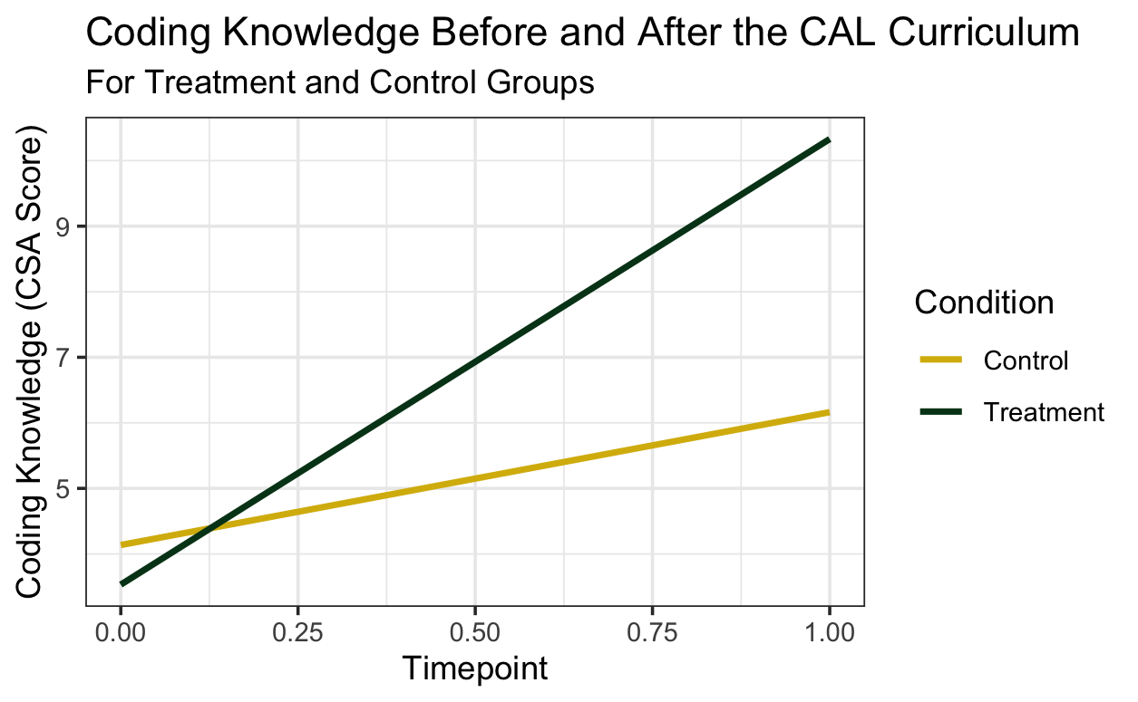

Computational thinking
Our second research question examined computational thinking as measured by the performance on the TechCheck assessment, again at two-time points, using a three-level regression nested by students and schools (Figure 3). The ICC of this model was 0.11. There was no significant effect of condition on TechCheck at baseline (p = .40). Relevant to our research question, there was both an overall significant effect of time on coding knowledge (δ_{0jk} = 1.06, p < .001) and a 1.07 point difference between the growth seen in the CAL group and the growth seen in the control group (p = .02).

Figure 3. Computational thinking before and after the CAL Curriculum.
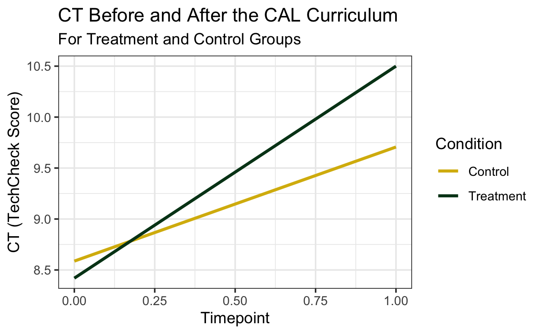

Significance
This paper describes the first large-scale evaluation of the CAL-ScratchJr curriculum and the Coding as Another Language pedagogy, more broadly, outside of the United States. The CAL-ScratchJr curriculum was developed in the United States to align with local standards and to meet the “evidence-based standards,” significantly affecting students’ learning of the ScratchJr coding language in a cluster-randomized control trial. However, there was no effect of curriculum on students’ computational thinking in the US-based trial (Bers et al., 2023).
In this study, we found that the adapted curriculum in Argentina successfully increased students’ knowledge of the ScratchJr coding language compared to students in the control condition and students’ computational thinking. This suggests that the CAL-ScratchJr curriculum applies to and is appropriate for the United States setting and can be adapted and used in other countries to improve student learning. Additionally, this suggests that adapting the CAL-ScratchJr curriculum to a local setting may lead to the curriculum having a more substantial effect than in the original randomized control trial. Future work should examine how the Varkey Foundation and local teachers adapted the curriculum to their local context to help better organizations and schools adapt and scale programs to students in Argentina, Latin America, and worldwide.

