ACTIVITY THEME What is the theme of your educational activity or project? | ACTIVITY SHOWCASE How will you showcase the children’s projects? Will you invite family or other classes?
PTD LEARNING GOALS Will this project integrate community building, content creation, creativity, collaboration, communication, or choices of conduct? How will you support learning of your chosen concept(s)?

ACTIVITY TIME FRAME How many hours will this take to complete? How will these hours be distributed? | ACTIVITY PREP What kinds of prep, research, building/programming, displays will the kids make/do leading up to the showcase?
GROUPING THE KIDS How will the kids be broken into partners or groups? Any remote/hybrid considerations? | SPECIAL ARRANGEMENTS Do any kids need special arrangements to complete the project?
MATERIALS What materials will your class need? | ASSESSMENTS What assessments will you be using & how do they relate to your PTD learning goals?
LOGISTICS Any other logistics that need to be planned for?

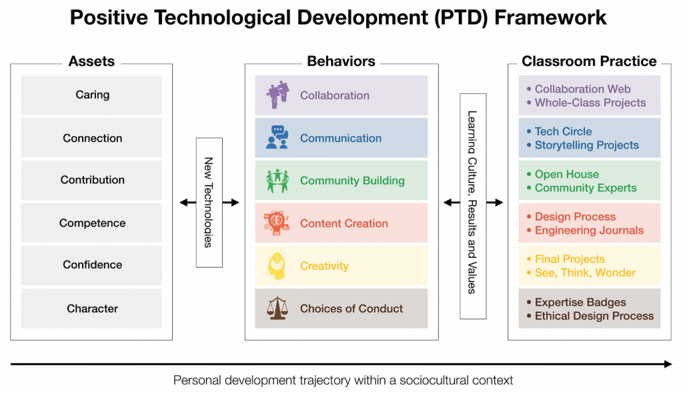
Assets  Internal character assets related to PTD behaviors (difficult to measure) | Behaviors  Ways children interact with technology (easy to observe) | Classroom Practice  How will you foster your chosen PTD behavior in your learning setting, with your students?
Caring | Collaboration
Connection | Communication
Contribution | Community Building
Competence | Content Creation
Confidence | Creativity
Character | Choices of Conduct
RESOURCE LINKS:
- Presentation Slides from this Bright Start Conference Event: https://docs.google.com/presentation/d/11zOt-0lgjJwC5-4m_YNKoJH9NkPI7Gq31D8VLJHQOhc/edit#slide=id.gdb030c841f_0_16
- PTD Framework Website: https://sites.tufts.edu/devtech/ptd/
  - Includes PTD engagement checklist for children, PTD engagement checklist for environments and facilitators, and PTD cards to print and use during planning meetings with your education team
- TEDx Presentation by Dr. Marina Bers on PTD: https://www.youtube.com/watch?v=jOQ-9S3lOnM
- DevTech Research Group Website: https://sites.tufts.edu/devtech/
- Early Childhood Technology (ECT) Graduate Certificate Program homepage: go.tufts.edu/ECT
- ECT Resource Links Page (Scroll to bottom for PTD-specific resources): https://sites.tufts.edu/devtech/certificate/
- DevTech & ECT Webinars Page: https://sites.tufts.edu/devtech/biography/webinars/

NOTES:

