Makerspace Values Card-Sorting Task

The goal of this task is to gain insight into what values you want your makerspace to promote in children.
- Work in small groups to complete two tasks about what we each value as “good making” in Kindergarten
- During each task, use pre-made cards to organize our ideas
- After each task, discuss as a group to learn your goals for the makerspace

In your discussions, think about the following questions:

What activities do you think would help children learn to be successful makers and learn the values you picked?
Use the Activity Cards, which contain activities, lessons, and projects that children might explore in a makerspace. As a group, sort the cards in order from your highest to your lowest priorities. If you think activities are useful in different ways, sort them accordingly.

What you want your children to learn and “take away” from their time in the makerspace?
Use the Values Cards, which contain learning goals, values, and skills that children could learn. As a group, sort these cards in order from your highest to your lowest priorities.
Plan to explain your choices to the rest of the group. Remember, this is just your opinion so there is no wrong answer!

design and build musical instruments that play sounds  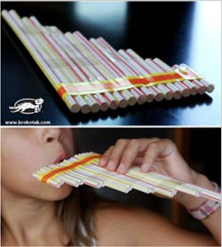 | makecostume masks, hats, and capes
Explore woodworking with child-size tools | Create a movie or a play using video equipment  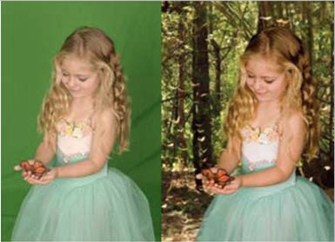
Participate as a class in a “global cardboard challenge” day | build a toy or structure for the classroom
build and program a dancing robot with KIBO | build a sailboat or paper airplane that will travel fastest or farthest  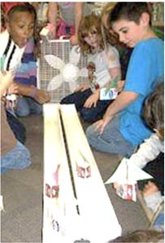
design and build a marble run | design a custom story, cartoon, or game on iPads with ScratchJr
Work with clay | design, prototype, and test solutions for community issues (e.g. community garden watering device)
Create a squishy “Play-doh” sculpture, lit with LEDs  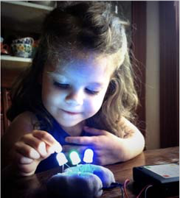 | Use sock puppets to make and record a short play
hand-make personal gifts for family and friends | Record audio of child or group explaining a unit concept
take apart and examine machines, like an old electric toy  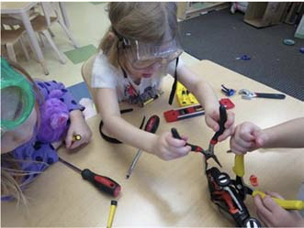 | build the tallest tower out of marshmallows and sticks
design and build a “class community” model, using a variety of tools  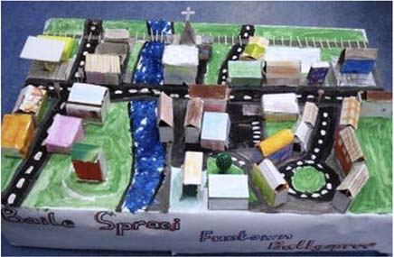 | design and build a sculptureout of clay, wire and beads
WILD CARD  Write in your own idea! | WILD CARD  Write in your own idea!
WILD CARD  Write in your own idea! | WILD CARD  Write in your own idea!

ARTS/  DRAMA | SCIENCE
COMPUTER  SCIENCE | ROBOTICS
FILM/  VIDEO | WILD CARD
MATH | SOCIAL/  EMOTIONAL
ENVIRONMENTAL/  STABILITY | ENGINEERING
CONFIDENCE | PERSEVERANCE
COLLABORATION | PROBLEM SOLVING
INDEPENDENCE | DESIGN THINKING
TROUBLESHOOTING | CRAFTSMANSHIP
SERVING THE COMMUNITY | ENTREPRENEURSHIP
HANDMADE/  DIY | PERSONALIZATION
“I made this!” | “It works!”
“I get it!” | “That was fun!”
CREATING INSTEAD OF CONSUMING | 3D PRINTING
SEWING | LEDs/  CIRCUITS
WOODWORKING | GLUE GUNS
AUDIO RECORDING | VIDEO CAMERA
HAND TOOLS (HAMMER, ETC.) | PROGRAMMING
DISCIPLINES | PERSONAL  MOTIVATION
LITERACY | FABRICATION  TECHNIQUES
SENSORY STIMULATION | FINE MOTOR (SMALL HAND MOVEMENTS)
GROSS MOTOR (BIG BODY MOVEMENTS) | WILD CARD
WILD CARD | WILD CARD

