A Suggested Format for IES 2015 Manuscript
John P. Jones¹, Thomas Jefferson¹ and Samuel Adams²

¹Affiliation No.1
Address
City, State Zip
Country

²Affiliation No.2
Address
City, State Zip
Country

Abstract
The abstract should be not more than 1 page in length and all the text except the title (14 pt) should be 12 pt Times New Roman font; 11 pt is acceptable if you need to reduce the length to meet the desired 8-page limit. 1” margins top, bottom, left and right are suggested. It is completely acceptable to use the abstract that was originally submitted to IES or update it if you have new results or conclusions to share. Since you are using MSWord or similar word processing software you can of course include equations and other non-alphanumeric characters in this version as well.

1. INTRODUCTION
Single spacing with double spacing between the paragraph and the heading and 1.5 line spacing after the heading. Section headings can be numbered and bold, all capitals, left margin aligned. Justified paragraph format should be used to maintain flush margins on both sides of the page. References should be inserted in square brackets, italicized except for year of publication [Franklin, et al., 1776; Revere and Paine, 1782]. Preferred format for references is shown in the reference section at the end of the template. References in this format should be in alphabetical order by the last name of the first author. One can also list references in square brackets by number in order of appearance in the manuscript, e.g., [4] denotes the fourth reference. Then the reference list simply contains the references with the corresponding number. Some people find this approach easier. Either approach is fine for IES.

2. OBSERVATIONS
Insert section headers as needed to organize your paper; subheadings (2.1, 2.2. etc) may also be used. Figures and tables should be inserted in the paper close to the text associated with each (rather than at the end of the document); figure labels may be bold face type. Figure 1 depicts solar activity for the previous two decades, including the projected smoothed sunspot number for the current solar cycle, #24. The precise placement of the figure depends on the text and, often, where MSWord will allow you to put it. The idea is to keep make it convenient for the reader to match the text with the associated figure without having to page back and forth in the document. Sometimes MSWord makes it difficult to place figures exactly as you might like to in the manuscript for reasons that are not entirely clear.

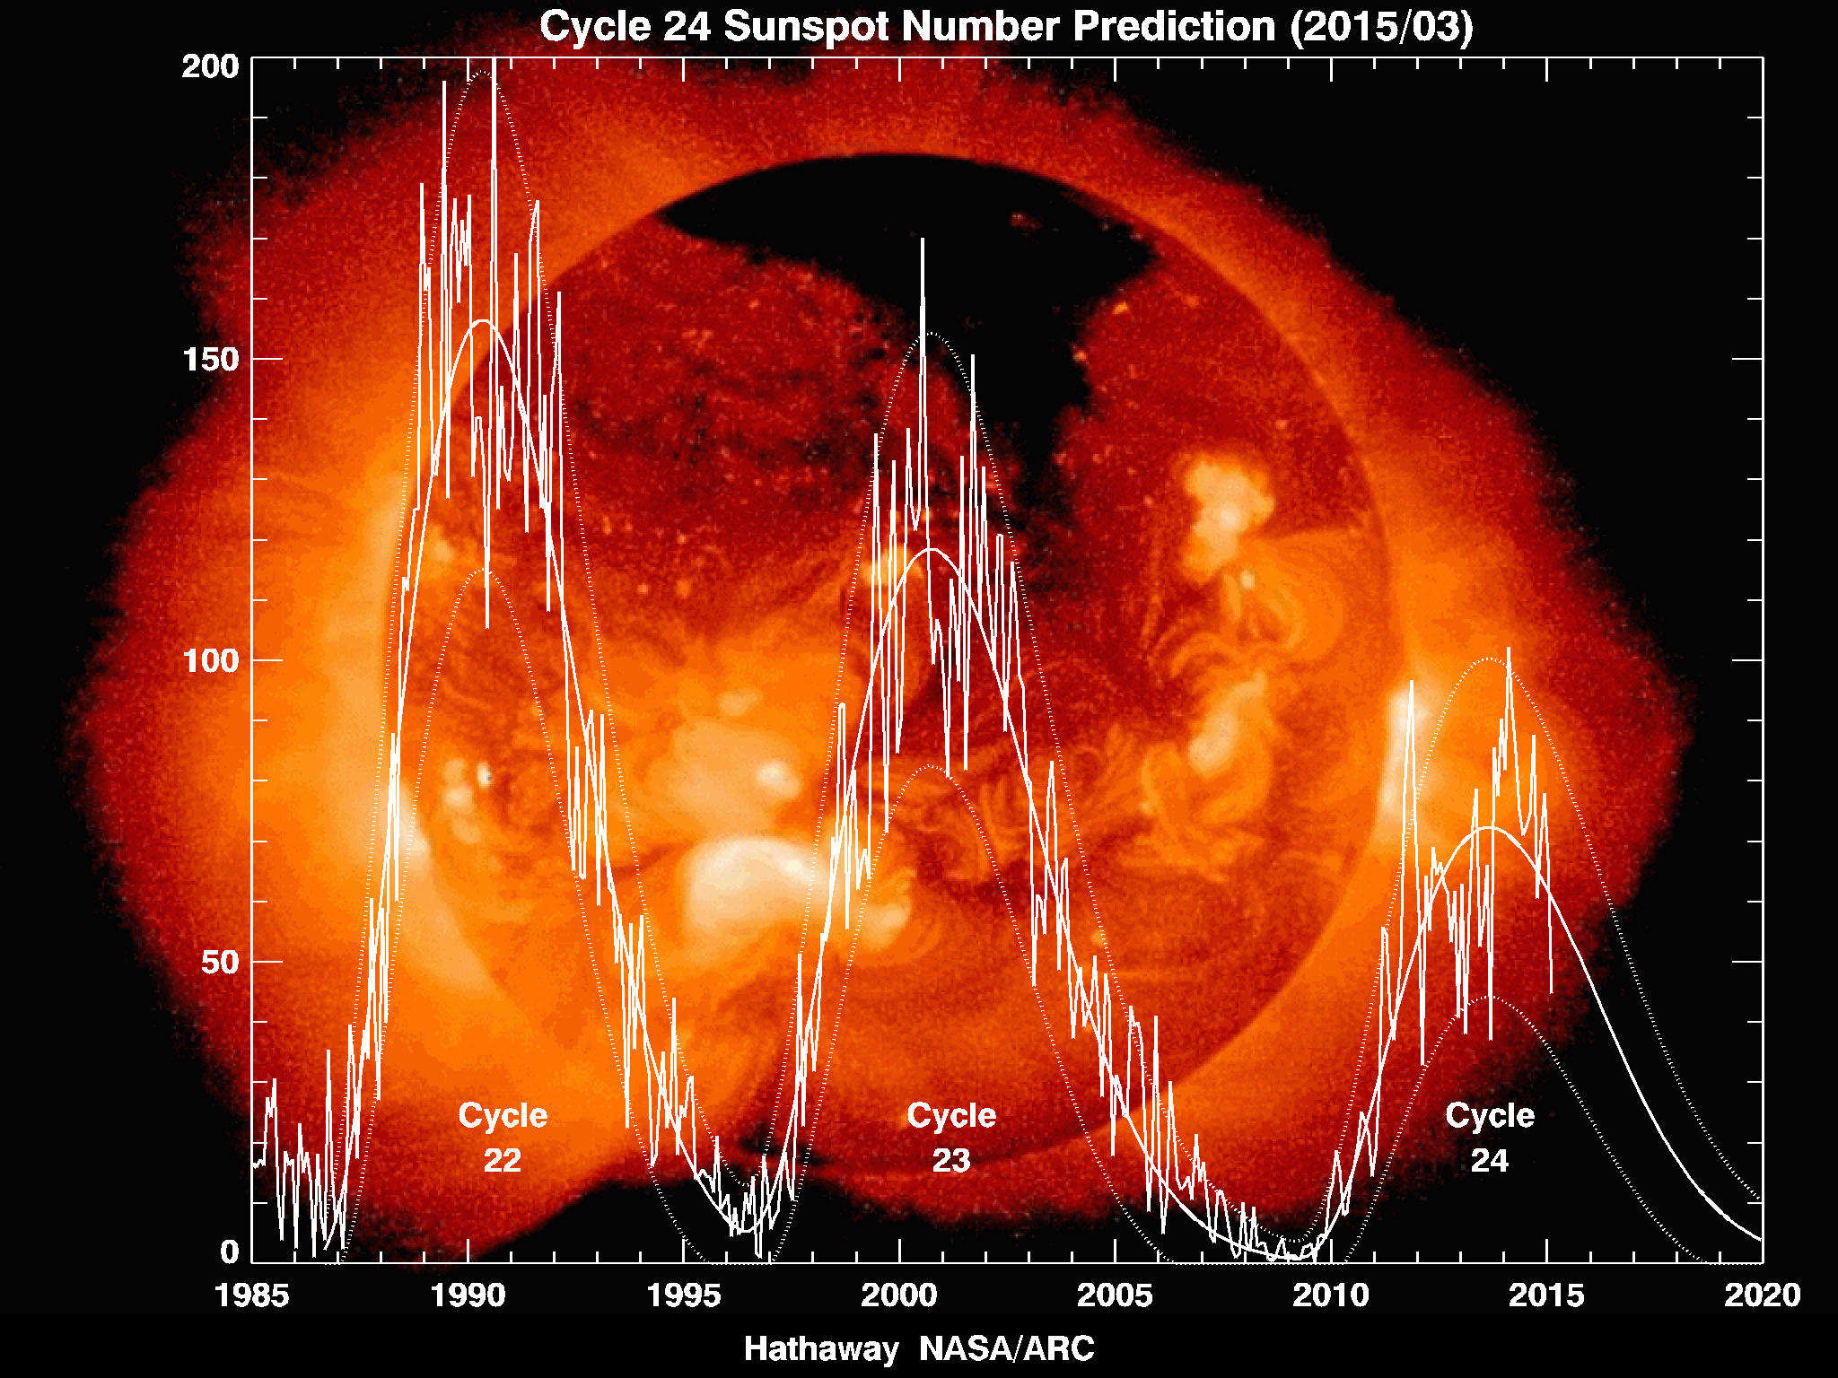
3.1 SUBSECTION HERE
Figure 1. Sunspot number as a function of year for solar cycles 22 thru 24. The plot shows both the observed sunspot numbers as well as the smoothed median sunspot numbers, projected out to the year 2020. Source: http://solarscience.msfc.nasa.gov/images/Cycle22Cycle23Cycle24big.gif
The subsection header uses the same format; you may also use the auto section numbering feature in MSWord if you prefer. Because this document is really a short paper it should not be necessary to use more than one level of subsection to organize the content effectively. Also, please include page numbers in the footnote, preferably centered on the page.

N. CONCLUSIONS
Always nice to draw some conclusions at the end of the paper to help your readers appreciate the results of your labors.

ACKNOWLEDGEMENTS
Authors may wish to acknowledge the contributions of non-coauthors or the source(s) of support for their work.

REFERENCES
Franklin, B., Adams, J. Q., & Washington, G. (1776). Formatting Techniques for the Ionospheric Effect Symposium: A Type-Setter’s Perspective. Advances in Formatting Research, 38(2), 232-238.
Revere, P. & Paine, T. (1782). A Rebel’s Common Sense Treatise on IES Standards and Procedures. Format Science, 32(5), 2047-2064.

